LVM

- Structure of LVM:
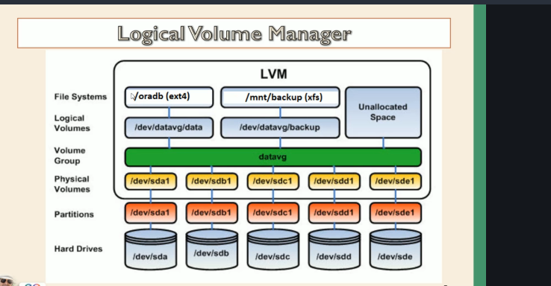

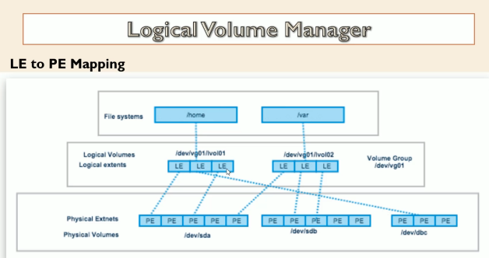

- To know the list of disk: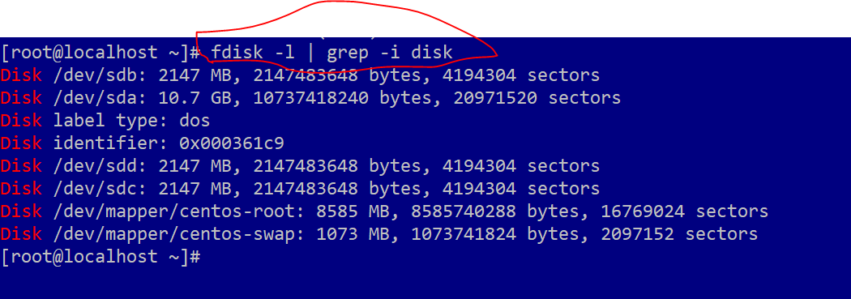
- After adding new disk to the linux server you need to scan the devices as below command:
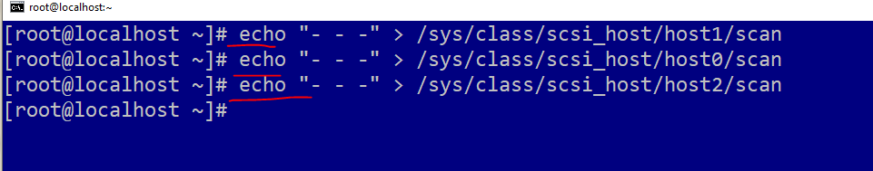

- Creating the partition on the disk:
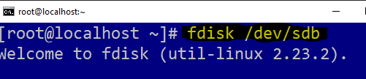


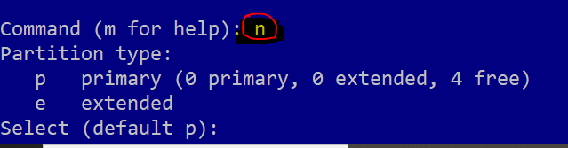
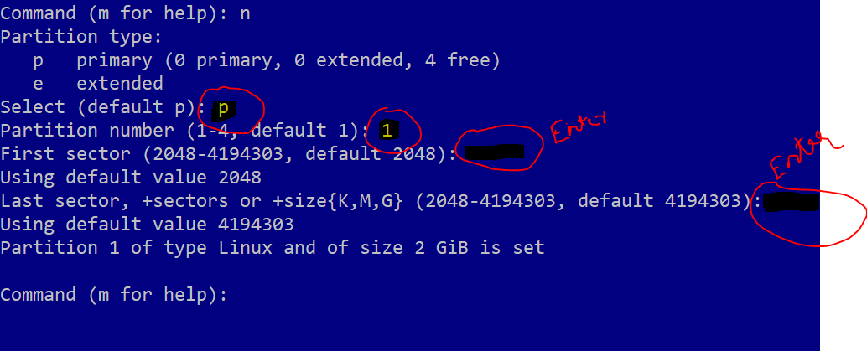
You can verify the partition which created
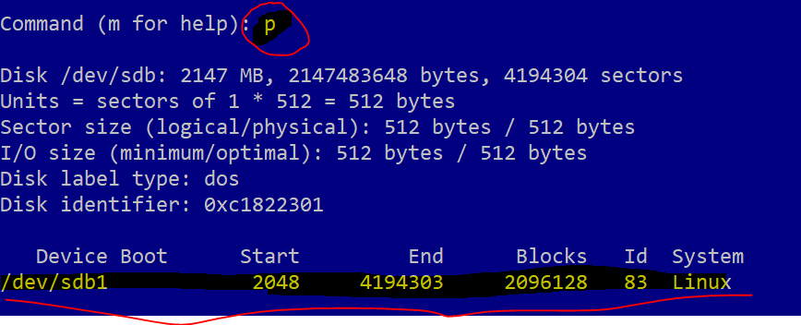

Crated partition is Linux one you need to change it to LVM 8e:
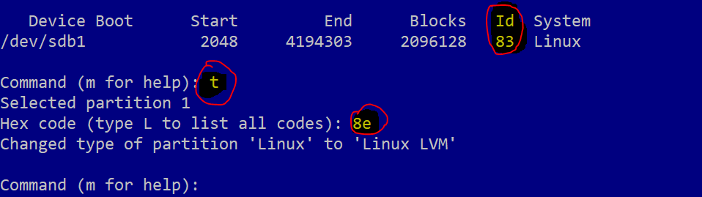

Save and come out W
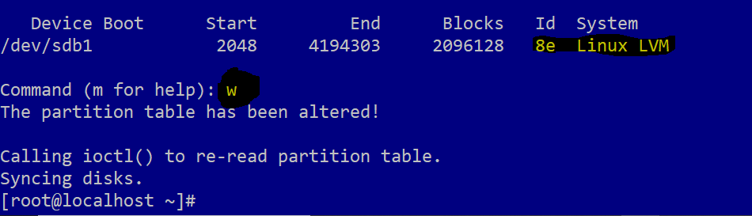

- List all the create physical partition:
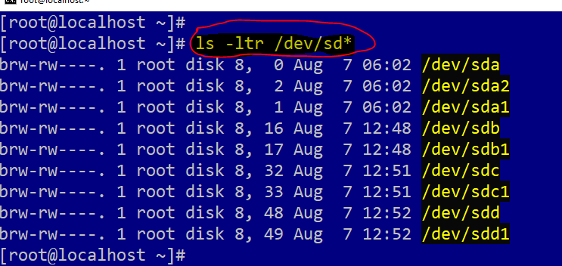

- Create the Physical volume PV:
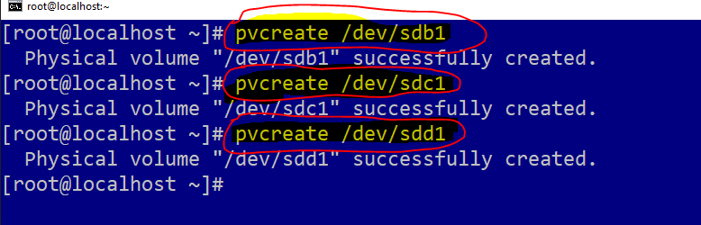

- To list the pv:
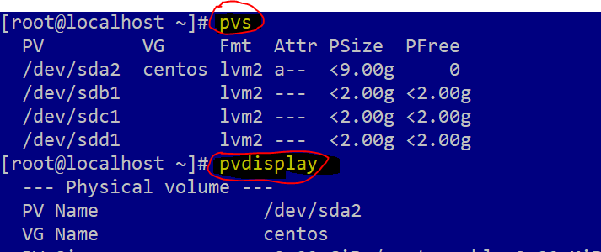
- Create the vg (Volume Group):
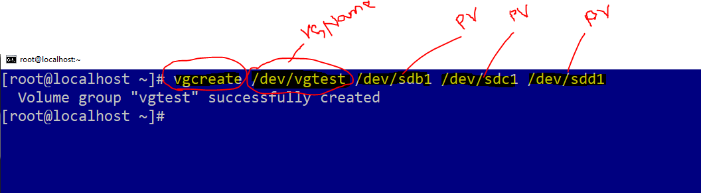

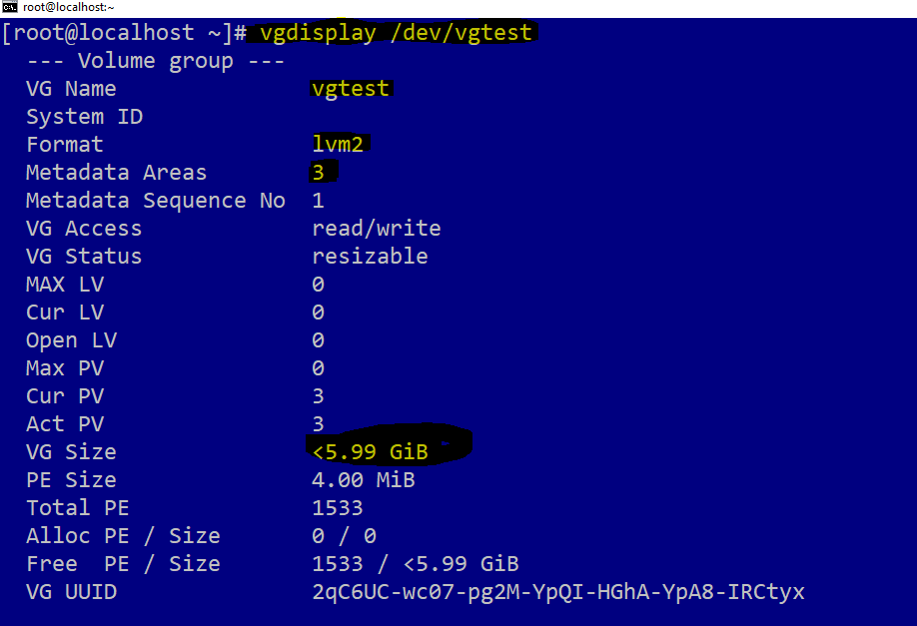
- Creation the Logical volume LV:
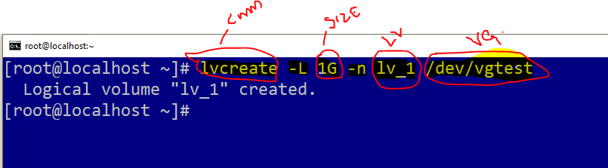
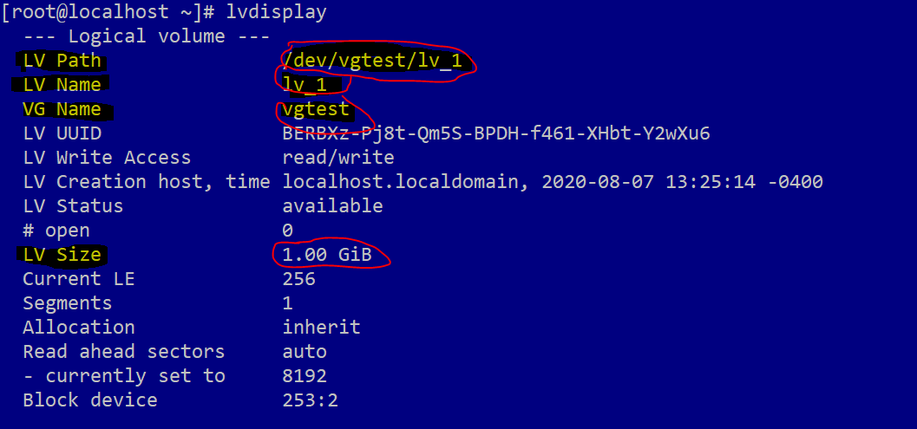

- You need to format the LV ( Logical volume):
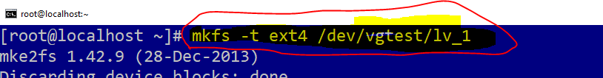

- You need to create the dir and mount the LV (Logical Volume)
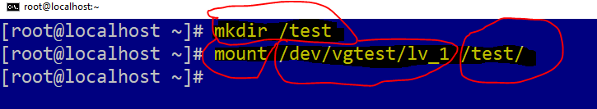

- You can see the logical volume has been mounted:
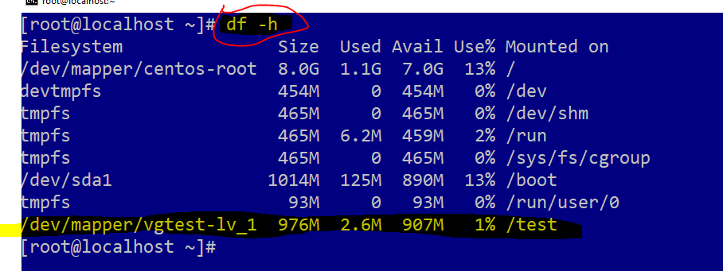

- For making permanent in volume, add into the fstab:
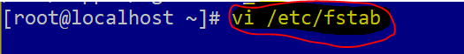
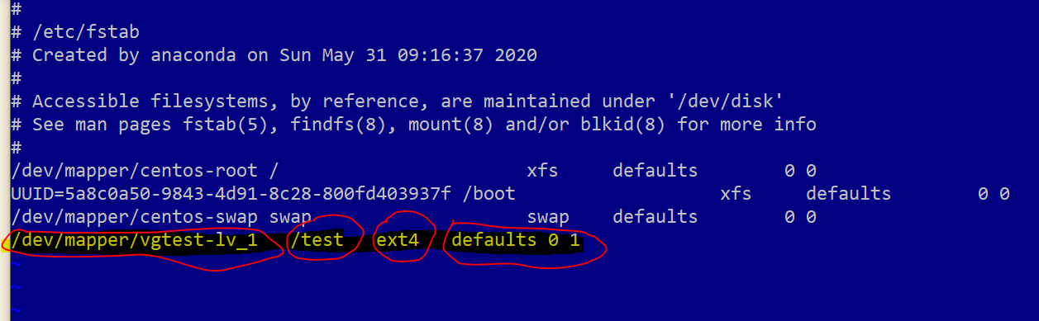
For test you can umount and mount:

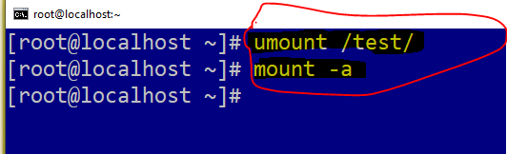

- Creating one more LV (Logical Volume) in same VG:
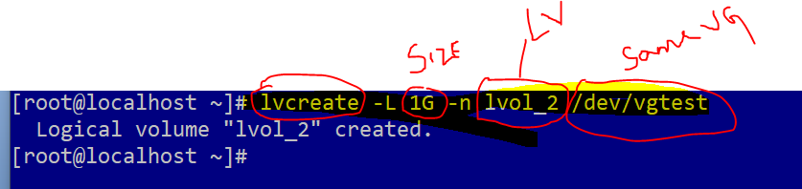

- Format the logical volume once you created:
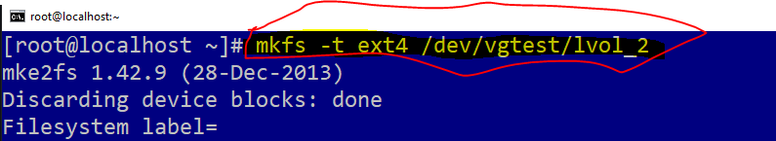

Create dir and mount it:
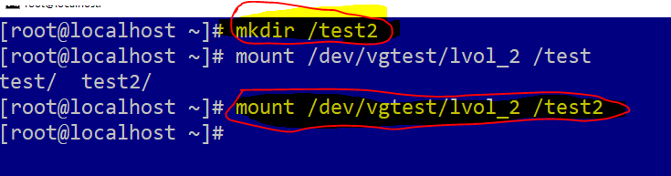
Add into the fstab for parment:
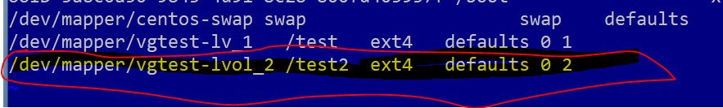

- Extend the file system:
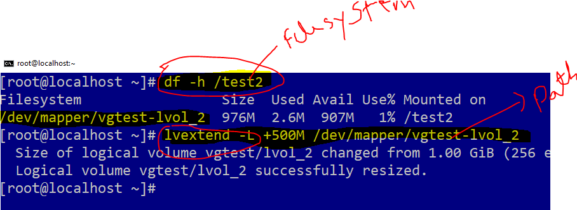
Resize2fs:
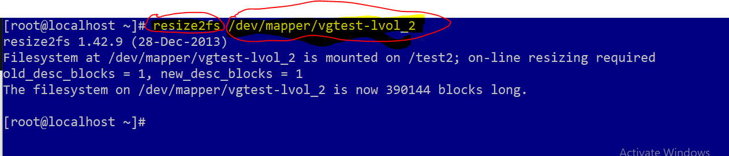

- Create one more LV:
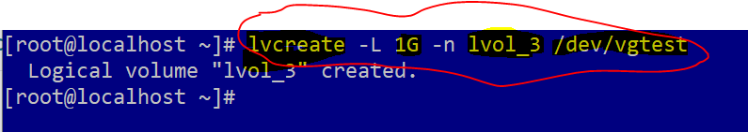

- LV extend:

df –hT
df -hP

